

**INVOICE PORTAL USER MANUAL**

**FOR**

**Federation of Indian Chambers of Commerce and Industry, FICCI**



Table of Contents

1. Invoice Portal Flow 3

2. Login Page 4

3. Dashboard 6

4. Sales Invoice 8

4.1 Create Sales Invoice 8

4.2 Sales Invoice Status 10

4.3 Convert Proforma to Tax Invoice 11

5. Sales Credit Note 12

5.1 Create Sales Credits Note 12

5.2 Sales Credits Note Status 13

6. Customer 14

6.1 Add New Customer 14

6.2 Customer Status 15

7. Dashboard (TL) 17

7.1 Approve Sales Invoice 18

7.2 Cancel Proforma Invoice 19

8. Sales Invoice Approver 20

8.1 Sales Invoice Approval Inbox 20

9. Sales Credit Note 21

9.1 Approval Inbox 21

~ Rest of Page Left Blank Intentionally ~

# Invoice Portal Flow

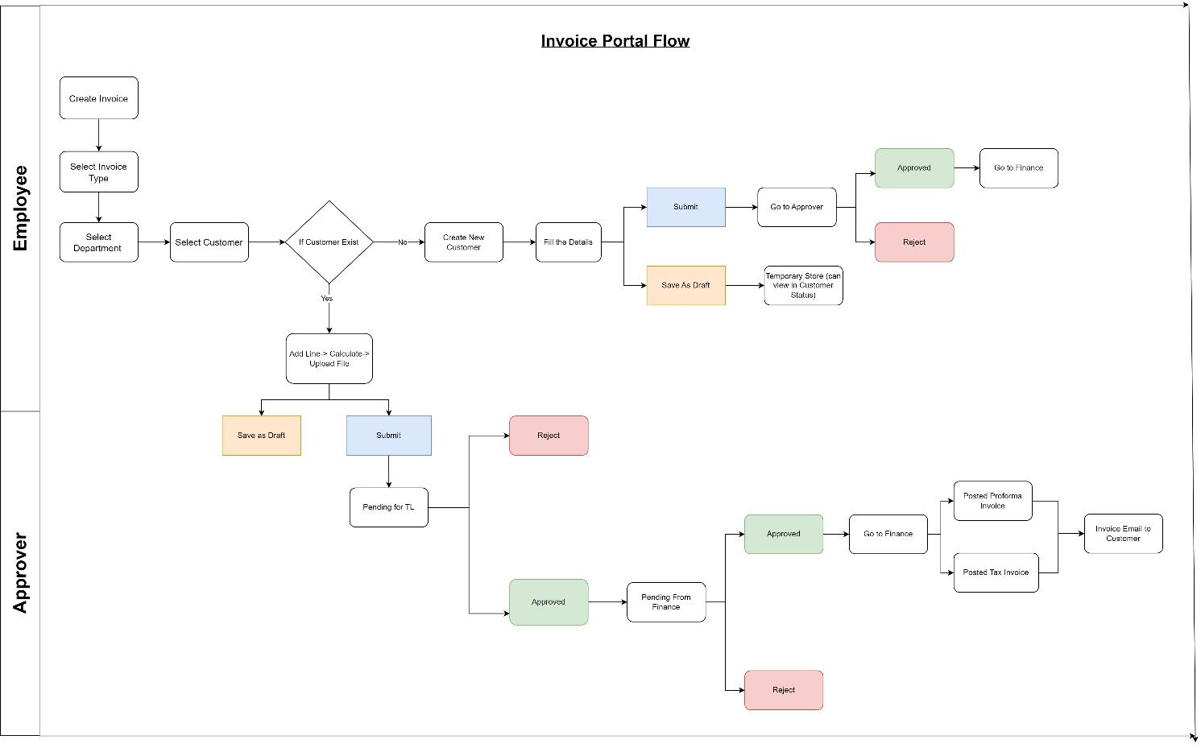

**[Click here to see the diagram](https://drive.google.com/file/d/1EBLZ3Ktz84_QN3BeTZ4Xril9ObpCP9B0/view?usp=sharing)**

**Please Note:** Because the following graphics appear pixelated due to document sizing, please refer to the diagram included in the email.

# Login Page

**Please Enter the URL Mentioned below in your web browsers such as Google Chrome, Microsoft Edge, or Firefox.**

Log in to <https://employeezone.ficci.in> with your email ID and password, once logged in Click on Invoice Portal Tile.

You can also go to <https://invoiceportal.ficci.in/login> and enter your email ID and password to Log in. Once you log in successfully, your Dashboard will open.

After Entering this URL, you will see the below page

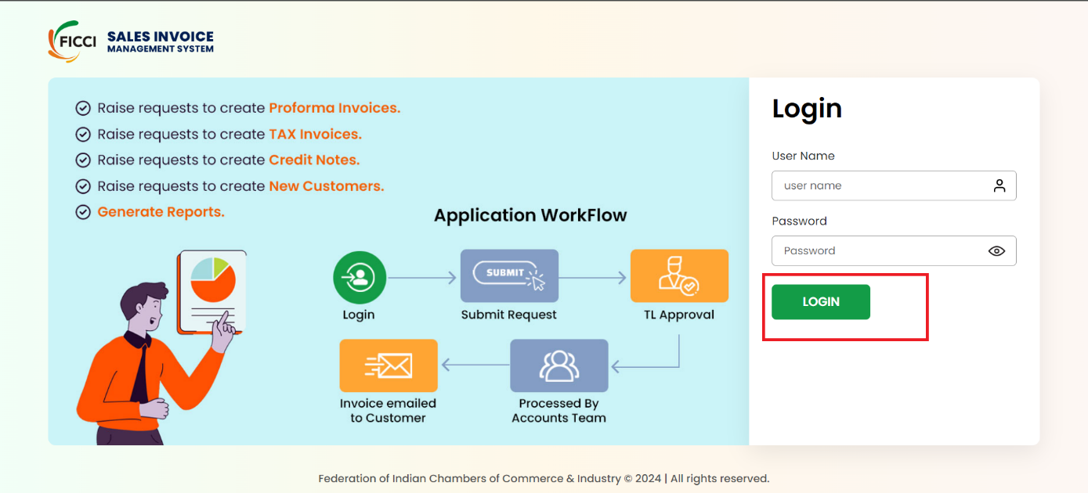

*Figure 1: Login Page*

Users can log in with a Username and Password to access the portal for:

1. **Employees**
2. **Approvers**
3. **Admin**

After logging in successfully, a notification will pop up confirming your login: "Success! You are now logged in." You'll then be redirected to the Dashboard Page.

**LOGIN FOR EMPLOYEE**

# Dashboard

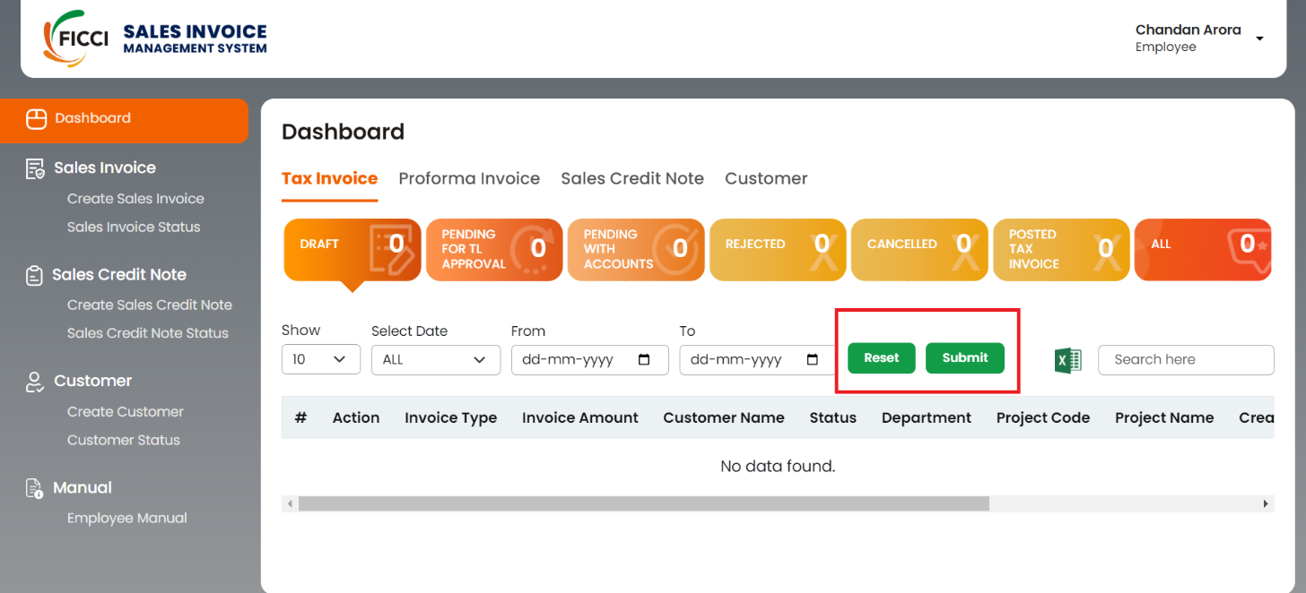

*Figure 2: Dashboard*

* The Dashboard is divided into four subsections, you can see the status by clicking on that tab.
  + **Tax Invoice**
  + **Proforma Invoice**
  + **Sales Credit Note**
  + **Customer**
* The user can find the Status of all sales Invoices by clicking on **Sale Invoice Status** button on the left side menu.
* Click on the dropdown to select from the following predefined date ranges: ALL, Today, Yesterday, Last 7 Days, Last 30 Days.
* If the user prefers to set a custom date range, use the FROM and TO calendar tabs. Click on the FROM tab to select the start date from the calendar. Click on the TO tab to choose the end date from the calendar.
* After selecting the desired date range, click on the **SUBMIT** button to apply the filter.
* The records in the subsection will be updated to display only those within the selected date range.
* To clear the date filters and view all records again, click on the **RESET** button.

# Sales Invoice



## **Create Sales Invoice**

On the left menu click on **Create Sales Invoice**, now under Invoice Type as per your requirement, select **Proforma Invoice** (for preliminary bills or estimated invoices) and **Tax Invoice** (for accounting and taxation purposes).

Users can first request a Proforma Invoice and later convert it into a Tax Invoice.

Users can cancel a Proforma Invoice but need to raise a **Sales Credit Note** request to reverse a Tax Invoice.

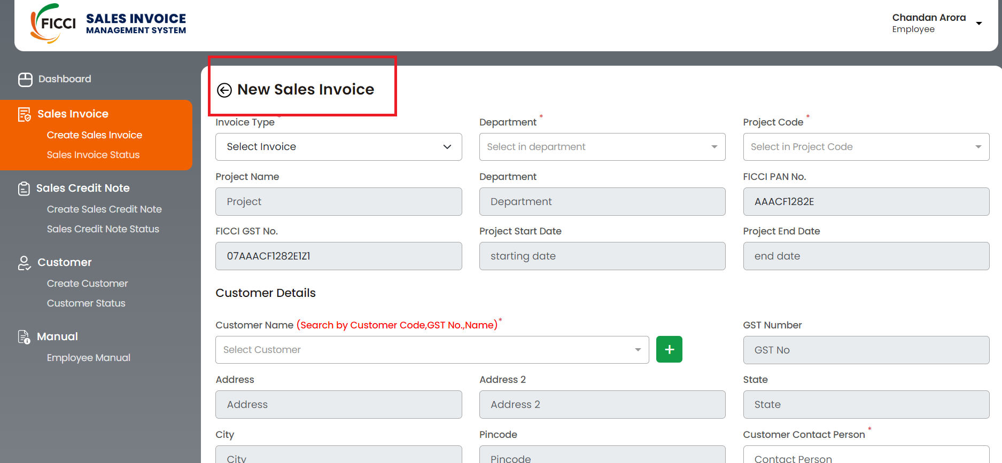

*Figure 3: Create Sales Invoice*

* Select the appropriate department and project codes from these dropdowns. Once selected, the remaining grey section will be filled automatically with related details.
* In the Customer Details section, select the customer's name from the dropdown menu.
* If the customer's name is not listed, user can add a new customer by clicking on the plus (**+**) button next to the dropdown.
* User can refer **Add New Customer** page.
* Once the user submits a new customer request, the Accounts team will approve the request, and then the user can create an invoice request against that customer.
* The user can track the customer request status from the **Customer Status** **Tab**.

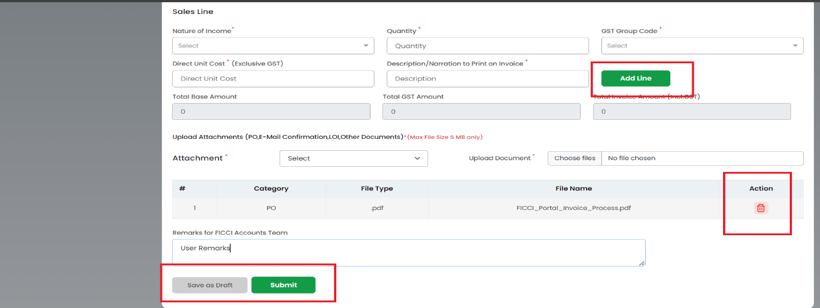

*Figure 3.1: Create Sales Invoice*

* Select the department and project code from the dropdown menu, other details will be filled automatically. In the Customer Details section, the user can select a customer name from a dropdown menu. You can search for customers by Organization Name, GST No. etc. Please verify the address and other details before going to the next step. Once you select the customer you may see a pop-up window of existing invoices of the selected customer, you can verify the list to avoid creating duplicate invoices.
* In the Customer Email ID field provide an email Id on which the sale invoice will be sent automatically from the system.
* Fill the necessary details in the Sales Line section. This includes the nature of Income, Quantities, GST Group Code, Direct Unit Cost (Excluding taxes), and Descriptions/Narration to print on the Invoice.
* After filling in the details for one-line item, click the **Add Line** button to add one or more additional line items to the invoice.
* Once the user has added all the necessary line items, Click the **Calculate** button to automatically calculate the IGST, CGST, and SGST based on the entered details.
* For uploading attachments, select the type of document you want to upload from the dropdown menu. Options include PO (Purchase Order), E-Mail Confirmation, LOI (Letter of Intent), and Other Documents.
* Click the **Choose Files** button to upload the selected document. After uploading, the file details will be displayed.
* In the **Action** column, users have the option to delete attachments if needed, as shown in Fig 3.1.
* User can enter any additional remarks for the FICCI accounts team in the provided remarks section. This step is optional.
* If the user wishes to save the invoice as a draft, uploading an attachment is optional. Click **Save as Draft** to save your progress and return to it later.
* If the user is ready to submit the invoice, uploading at least one attachment is mandatory. Click **Submit** to send the invoice for approval to the Team Leader.

## **Sales Invoice Status**

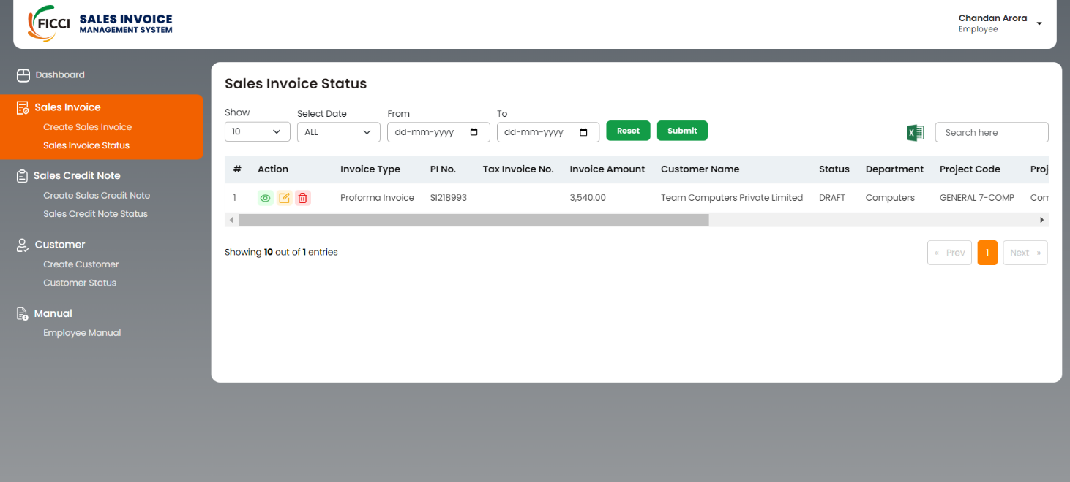

*Figure 4: Sales Invoice Status*

* The Sales Invoice Status page allows users to filter, search, and manage their invoices effectively.
* Click on the dropdown menu next to Date and select a predefined date range such as ALL, Today, Yesterday, Last 7 Days, and Last 30 Days.
* Use the FROM and TO calendar tabs to select a custom date range. After selecting the date range and user, click the **Submit** button to apply the filters.
* The filtered list will display customer details for both Proforma Invoices and Tax Invoices.
* Use the **Search Here** section to find a customer by entering various details such as customer name, invoice number, etc. (excluding the Record No.).
* To adjust the number of records displayed, click on the **Show** dropdown menu and select the desired number (up to a maximum of 100 records).
* To navigate to the next or previous page, use the buttons located at the bottom right corner of the page.
* In the Action Section user can View, Edit, Download, and Delete.

## **Convert Proforma to Tax Invoice**

Users can convert Proforma Invoice to Tax Invoice once the proforma invoice is processed by the Accounts department. This does not require TL approval as the proforma Invoice was already approved by TL.

Steps to Follow:

**Go to Dashboard ---> Proforma Invoice --- > PI Process (Account) --- > click on View icon**

At the bottom user will find **Convert** to Invoice.

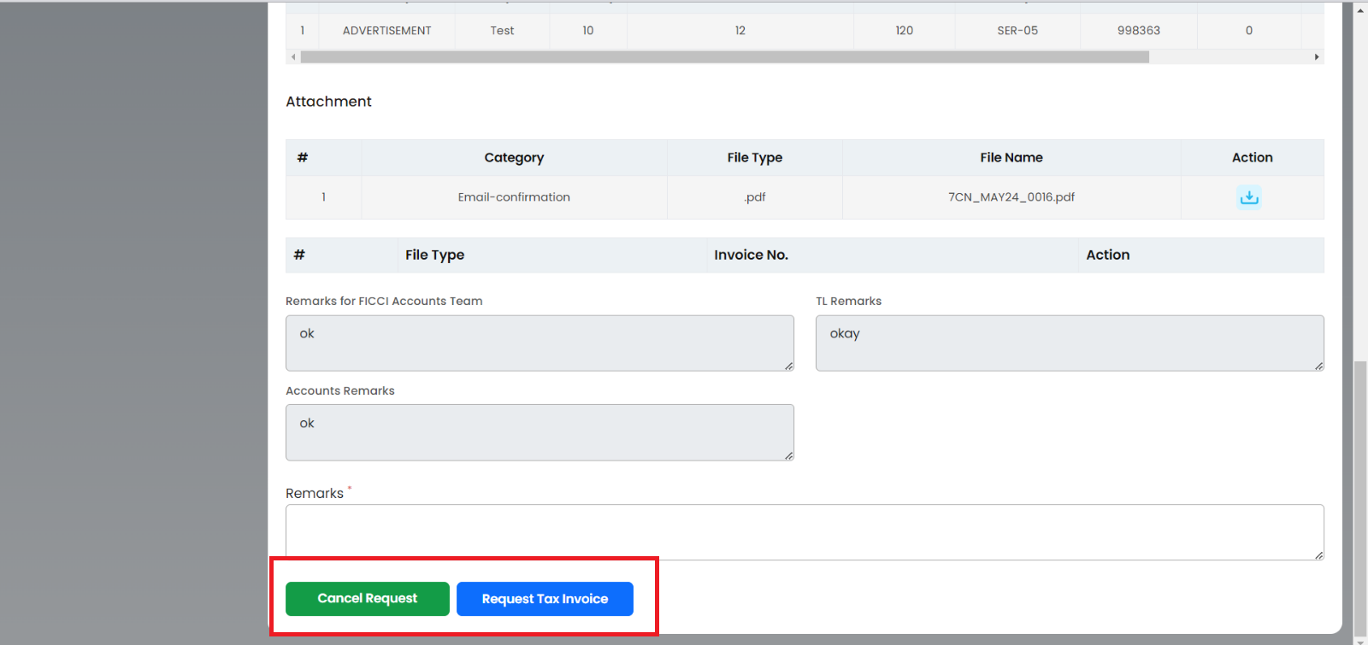

*Figure 5: Convert Proforma to Tax Invoice*

# Sales Credit Note



## **Create Sales Credits Note**

To reverse or cancel any Posted Tax Invoice, the User needs to create a Credit Sales Note request.

Credit Sales Note will need TL approval with the refund or without refund.

Credit Sales Note will need TL and CH approval if the refund amount is more than INR 50000.

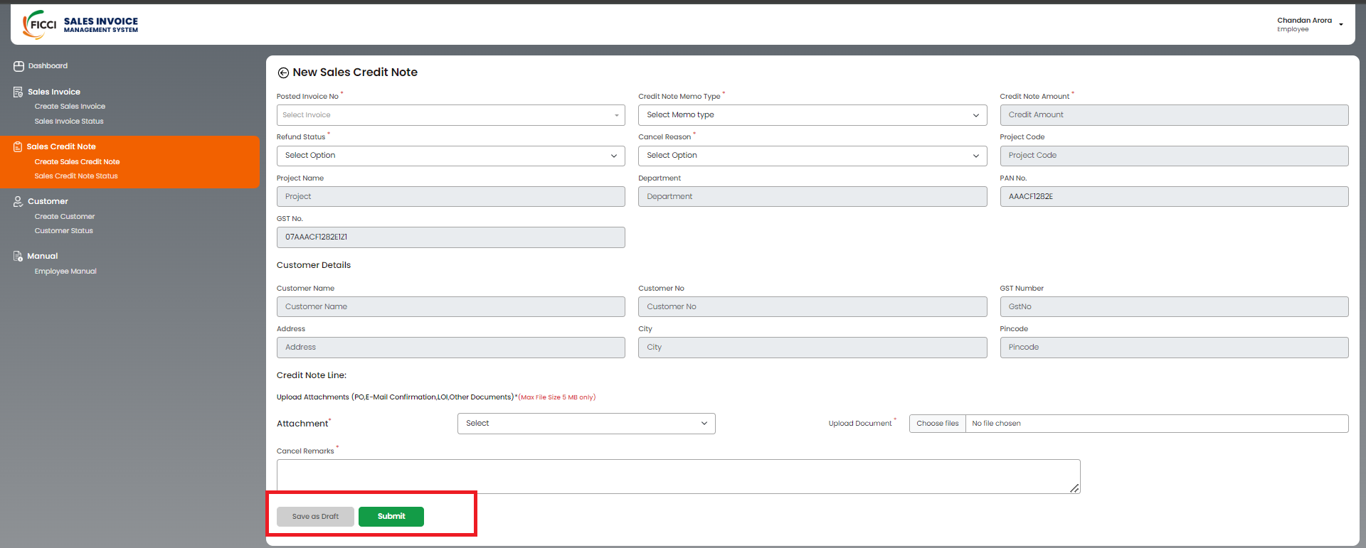

*Figure 6: Create a Sales Credit note*

* In Sales Credit Note, for **New Sales Credit Note**, the User has to Select Posted Invoice No and from Credit Note Memo Type, the User can select **Partial or** **Full** reversal. In the case of Partial user needs to provide the required credit note amount. In Refund Status user needs to select the option from with refund or without refund.
* And the remaining grey section will be filled automatically with the details from the selected invoice.
* Click on Select Option to choose the Cancel Reason and available options are Duplicate, Data Entry Mistake, Service not availed, Amount Credited by Mistake, and Change in Invoice Date.
* In the Credit Note Line, to upload supporting documents.
* Click the **Choose files** button to upload the selected document. After uploading, the file details will be displayed, allowing the user to confirm the correct files have been uploaded.
* Provide mandatory cancel remarks in the designated field. This is required to give context and reason for the credit note.
* Click **Save as Draft** if you need more time or want to review later.
* Click **Submit** once all details are accurate and attachments are uploaded and send the invoice for approval to the Team Leader.

## **Sales Credits Note Status**

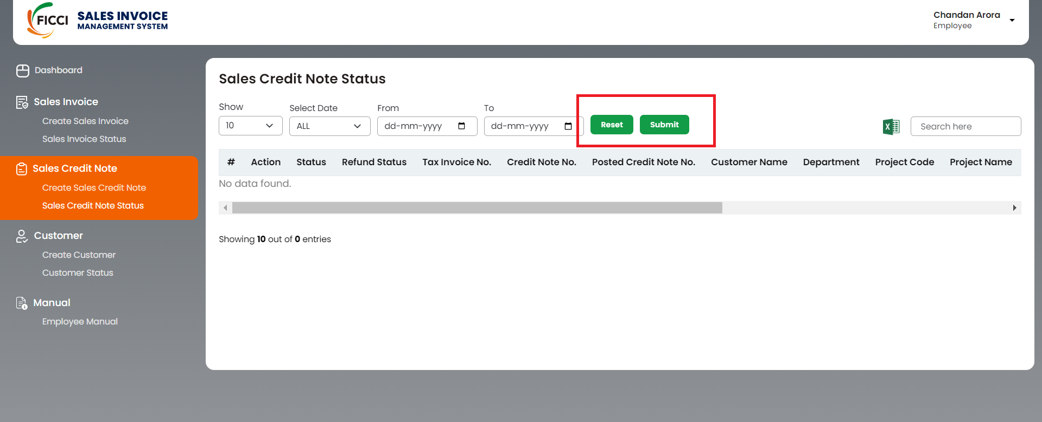

*Figure 7: Sales Credit Note Status*

* On the Sales Credit Note Status page, users can track the status of their sales credit notes and perform various actions.
* Users can filter sales credit notes by date using the provided options. After selecting the desired date range, users can click on the **Submit** button to apply the filter. Users can reset the filters by clicking the **Reset** button if needed.
* Utilize the **Search Here** section to find a customer by entering various details such as customer name, invoice number, etc. (excluding the Record No.).
* Users can choose the number of records displayed per page by clicking on the dropdown menu in the **Show** option. The maximum number of records per page is 100.
* To move to the next or previous page of records, users can use the navigation buttons located in the bottom right corner of the page.
* In the Action section, users can view or delete sales credit notes.

# Customer



## **Add New Customer**

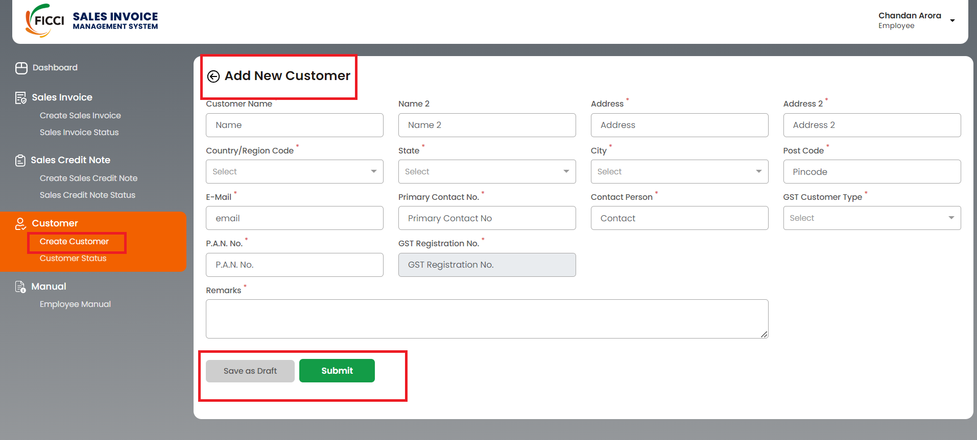

*Figure 8: Create Customer*

* The user has to fill in all the mandatory details required to **Add a new customer**.
* If the user tries to add a customer name that already exists, a pop-up message (*Customers with the same PAN Number and different GST Number already exist OR same GST Number*) will appear on the screen. Users can still create a customer with a different address.
* If the City Pin is not available then the user can contact the FICCI accounts team.
* Case 1: Clicking on the **Save as Draft** button after entering customer details saves the data temporarily and makes it viewable and editable on the Customer Status page.
* Case 2: Clicking on the **Submit** button after entering customer details will directly submit the data and make it viewable on the Customer Status page. The details are then sent to the FICCI Accounts department for approval.

## **Customer Status**

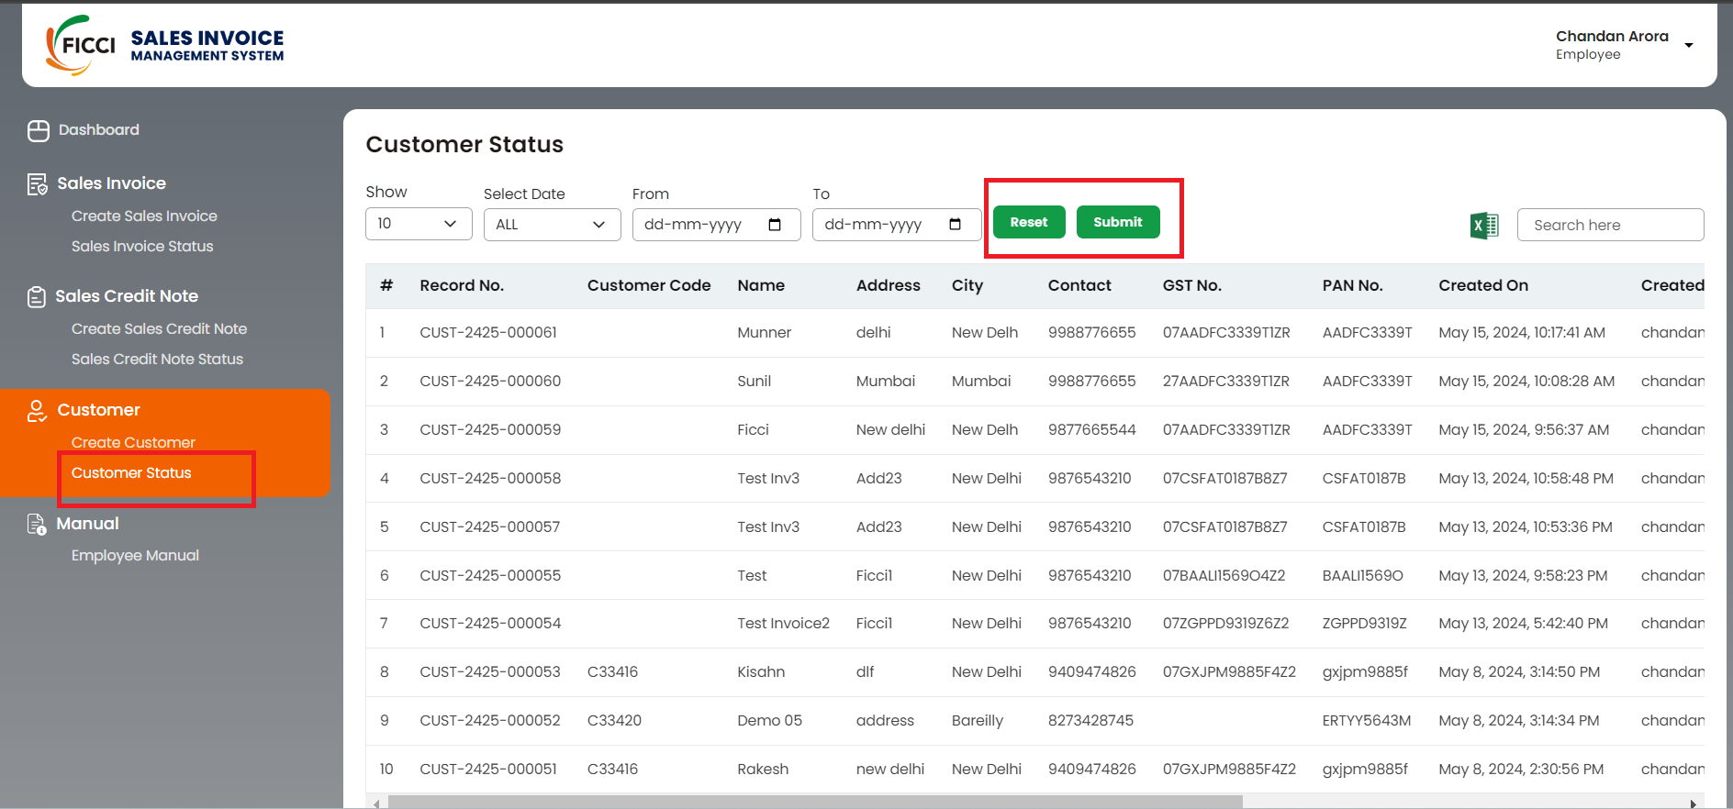

*Figure 9: Customer Status*

* On the **Customer Status** page, users can view customer details, search for specific customers, and navigate through records with date filters and pagination options.
* Users can filter customer status by date using the provided options. After selecting the desired date range, users can click on the **Submit** button to apply the filter. Users can reset the filters by clicking the **Reset** button if needed.

**LOGIN FOR APPROVER**

# Dashboard (TL)

The Approver Dashboard is divided into four subsections, you can see the status by clicking on that tab.

* **Tax Invoice**
* **Proforma Invoice**
* **Sales Credit Note**
* **Customer**

TL can go to **FOR APPROVAL BUCKET** to see all the Tax Invoices, Proforma Invoices, and Sales Credit Note Invoices to either approve or reject the request.

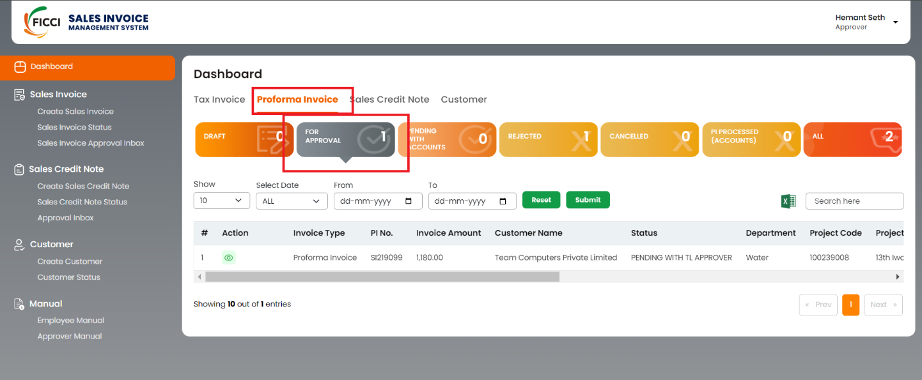

*Figure 10: Dashboard (Proforma Invoice)*



## **Approve Sales Invoice**

* By Clicking on the View Icon under the Action, the Sales Invoice Approval request will open with all the details. Where the user will get the option to **Approve** or **Reject** the pending request as shown in Figure 11.

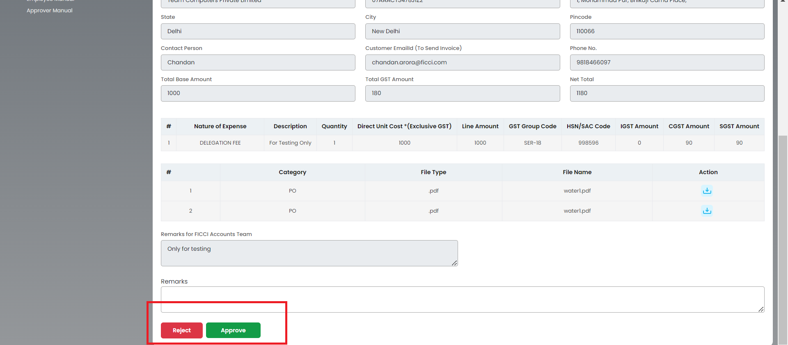

*Figure 11: Proforma Invoice (sales Invoice Approver Inbox)*

In the case of Tax Invoice under the Action section, users can View, download, and find payment information by clicking on the buttons as shown in Fig 12.

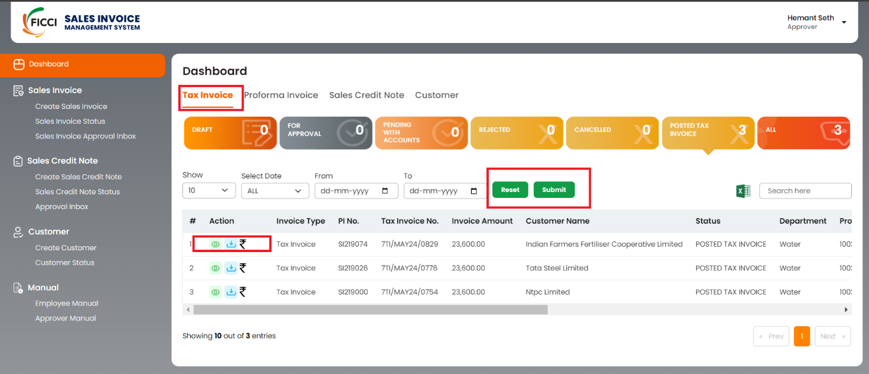

*Figure 12: Dashboard (Tax Invoice)*

* Click on the dropdown to select from the following predefined date ranges: ALL, Today, Yesterday, Last 7 Days, Last 30 Days.
* If the user prefers to set a custom date range, use the FROM and TO calendar tabs. Click on the FROM tab to select the start date from the calendar. Click on the "TO" tab to select the end date from the calendar.
* After selecting the desired date range, click on the **SUBMIT** button to apply the filter.
* To clear the date filters and view all records again, click on the **RESET** button.
* Use the **Search Here** section to find a customer by entering various details such as customer name, invoice number, Invoice type, Invoice amount, etc.
* In the Action section, users can View, download, and find payment information by clicking on buttons as shown in Fig 12.

## **Cancel Proforma Invoice**

Users can cancel the proforma invoice once it's processed by the accounts team. This request will go for TL approval.

Steps to Follow:

**Go to Dashboard ---> Proforma Invoice --- > PI Process (Account) --- > click on View icon**

At the bottom user will find **Cancel** to Invoice.

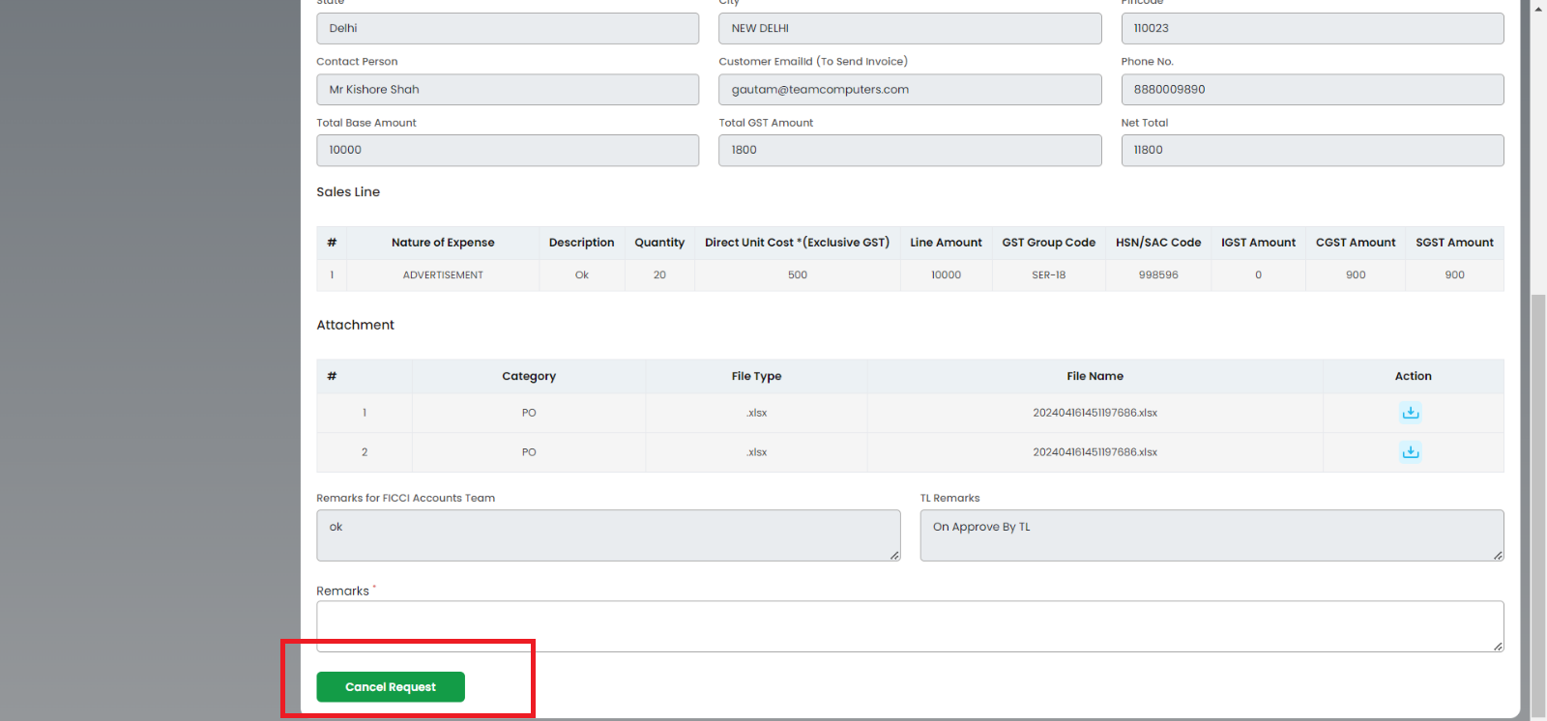

*Figure 13: Cancel Proforma Invoice*

# Sales Invoice Approver



## **Sales Invoice Approval Inbox**

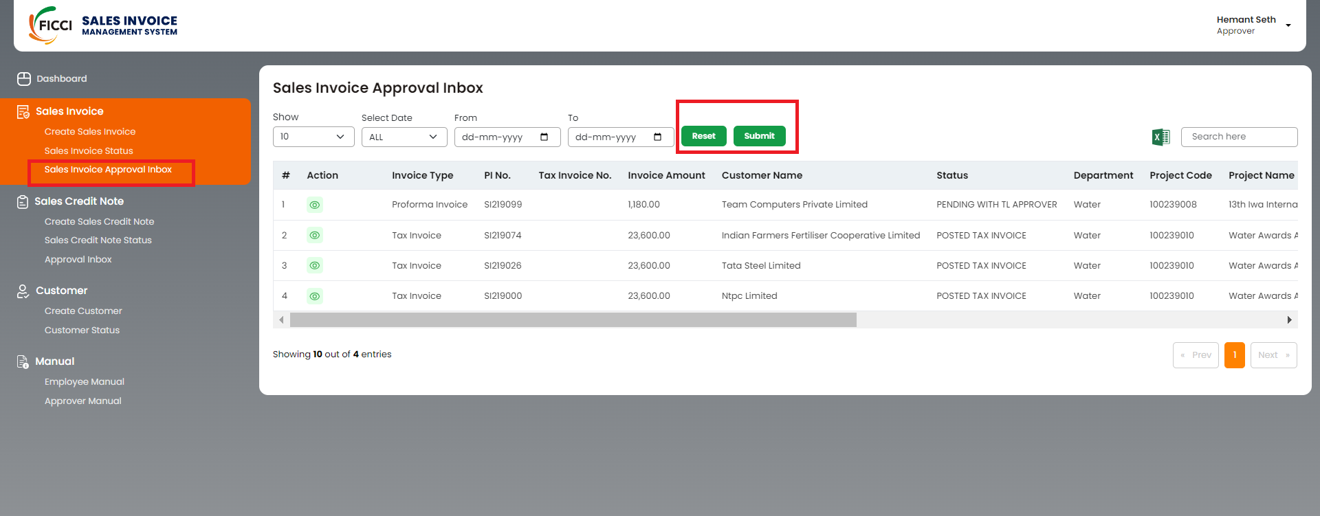

*Figure 14: Sales Invoice Approval Inbox*

* On the Sales Invoice approval page, users can track the status and perform various actions.
* Users can filter sales credit notes by date using the provided options. After selecting the desired date range, users can click on the **Submit** button to apply the filter. Users can reset the filters by clicking the **Reset** button if needed.
* Utilize the **Search Here** section to find a customer by entering various details such as customer name, invoice number, etc.
* Users can choose the number of records displayed per page by clicking on the dropdown menu in the **Show** option. The maximum number of records per page is 100.
* To move to the next or previous page of records, users can use the navigation buttons located in the bottom right corner of the page.
* In the Action section, users only can view sales invoice approval.

# Sales Credit Note



## **Approval Inbox**

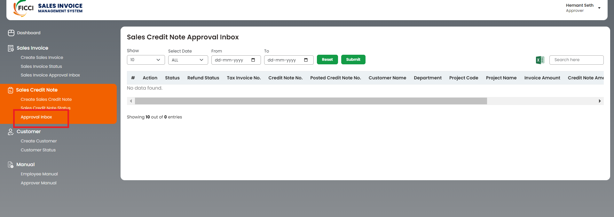

*Figure 15: Approval Inbox*

* On the Sales Credit Note Approval Inbox page, users can find the approval inbox.
* Choose a date range using the From and To fields, then click Reset or Submit to filter results.
* Search for Customer: Enter customer details (excluding Record No.) in the Search Here section to find specific records.
* Use the **Show** dropdown to view up to 100 records per page.
* Click the navigation buttons in the bottom right corner to move between pages.
* Use the slide bar in the Action section to view the approval status by the approver.

**Thank You**